LCD 1602 - Autoscroll

The Liquid Crystal Library allows you to control LCD displays that are compatible with the Hitachi HD44780 driver. There are many of them out there, and you can usually tell them by the 16-pin interface.

This example sketch shows how to use the autoscroll() and noAutoscroll() methods to move all the text on the display left or right.

autoxscroll() moves all the text one space to the left each time a letter is added

noAutoscroll() turns scrolling off

This sketch prints the characters 0 to 9 with autoscroll off, then moves the cursor to the bottom right, turns autoscroll on, and prints them again.

Hardware Required

* Arduino or Genuino Board
* LCD Screen (compatible with Hitachi HD44780 driver)
* pin headers to solder to the LCD display pins
* 10k ohm potentiometer
* 220 ohm resistor
* hook-up wires
* breadboard

Circuit

Before wiring the LCD screen to your Arduino or Genuino board we suggest to solder a pin header strip to the 14 (or 16) pin count connector of the LCD screen, as you can see in the image above.

To wire your LCD screen to your board, connect the following pins:

* LCD RS pin to digital pin 12
* LCD Enable pin to digital pin 11
* LCD D4 pin to digital pin 5
* LCD D5 pin to digital pin 4
* LCD D6 pin to digital pin 3
* LCD D7 pin to digital pin 2

Additionally, wire a 10k pot to +5V and GND, with it's wiper (output) to LCD screens VO pin (pin3). A 220 ohm resistor is used to power the backlight of the display, usually on pin 15 and 16 of the LCD connector

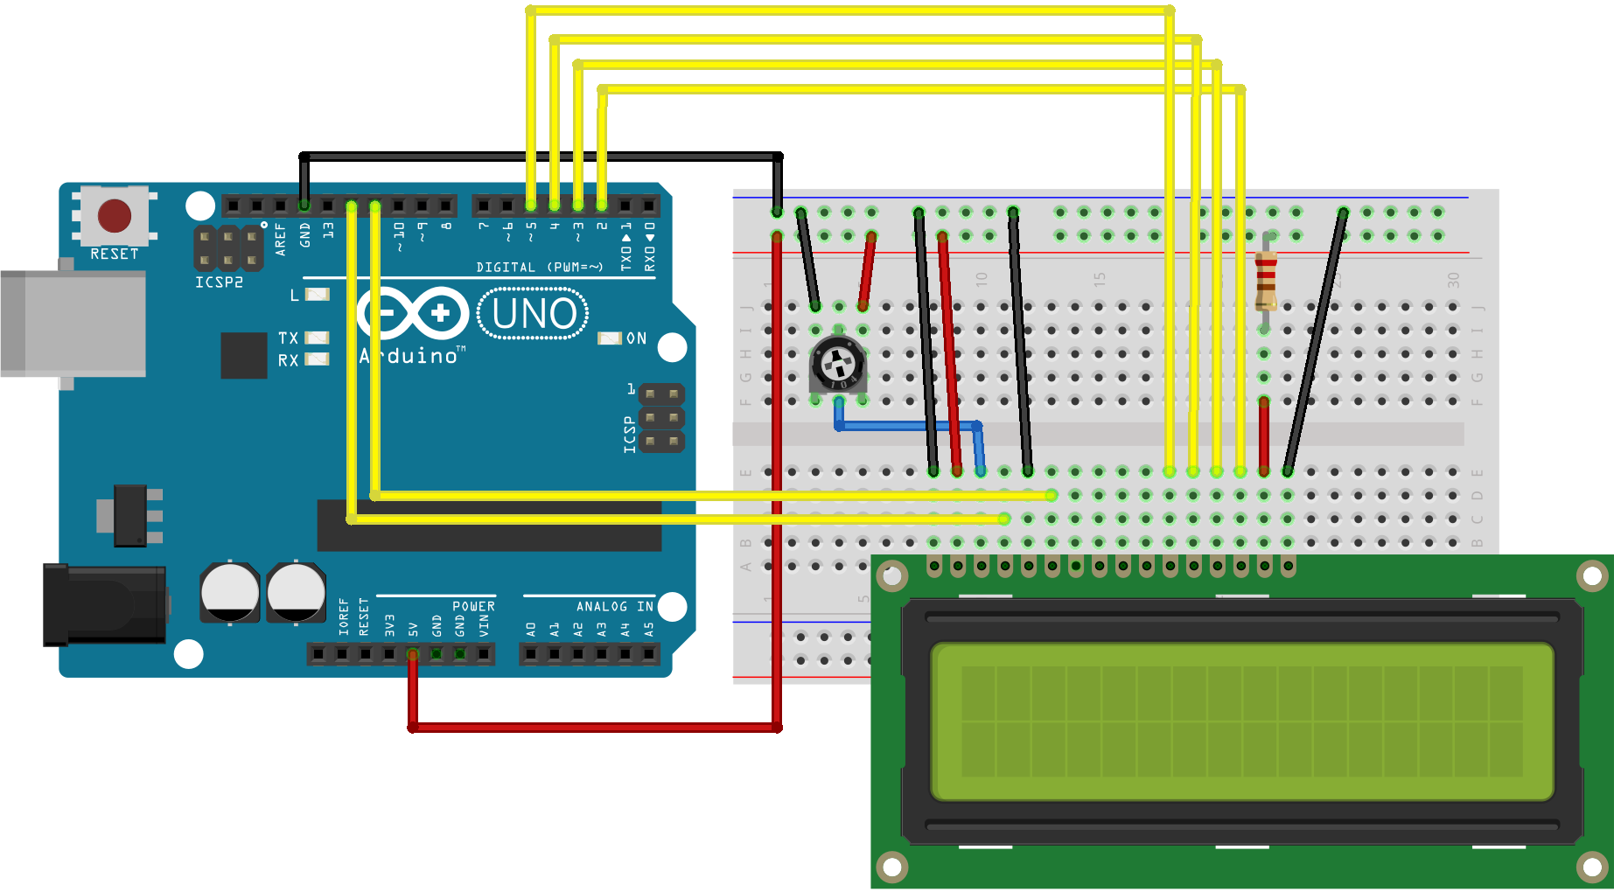

Schematic

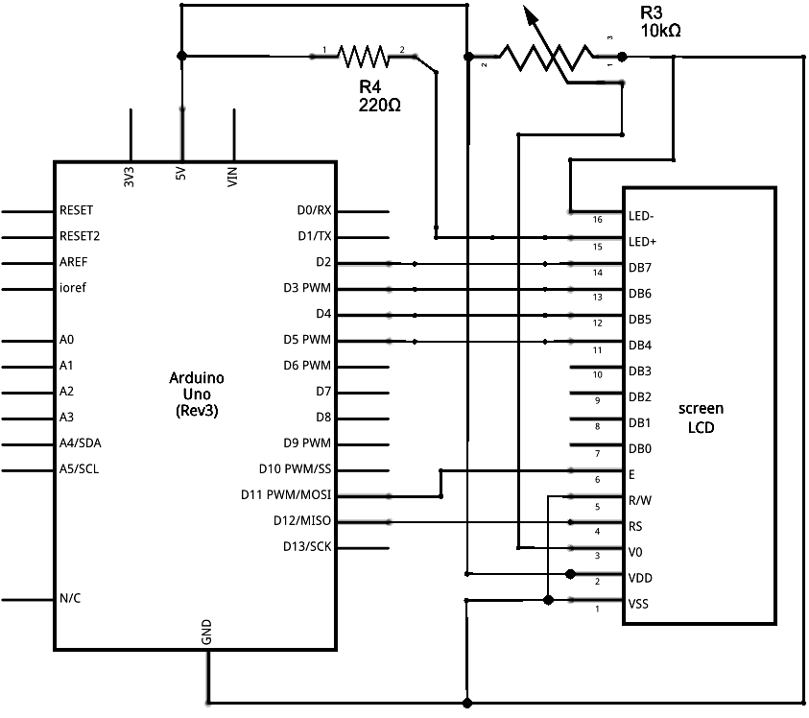

Code

*// include the library code:*  
#include <LiquidCrystal.h>  
  
*// initialize the library by associating any needed LCD interface pin*  
*// with the arduino pin number it is connected to*  
const int rs = 12, en = 11, d4 = 5, d5 = 4, d6 = 3, d7 = 2;  
LiquidCrystal lcd(rs, en, d4, d5, d6, d7);  
  
void **setup**() {  
  *// set up the LCD's number of columns and rows:*  
  lcd.begin(16, 2);  
}  
  
void **loop**() {  
  *// set the cursor to (0,0):*  
  lcd.setCursor(0, 0);  
  *// print from 0 to 9:*  
  for (int thisChar = 0; thisChar < 10; thisChar++) {  
    lcd.print(thisChar);  
    delay(500);  
  }  
  
  *// set the cursor to (16,1):*  
  lcd.setCursor(16, 1);  
  *// set the display to automatically scroll:*  
  lcd.autoscroll();  
  *// print from 0 to 9:*  
  for (int thisChar = 0; thisChar < 10; thisChar++) {  
    lcd.print(thisChar);  
    delay(500);  
  }  
  *// turn off automatic scrolling*  
  lcd.noAutoscroll();  
  
  *// clear screen for the next loop:*  
  lcd.clear();  
}